Councillor Ntandokazi Capa - Southern Africa

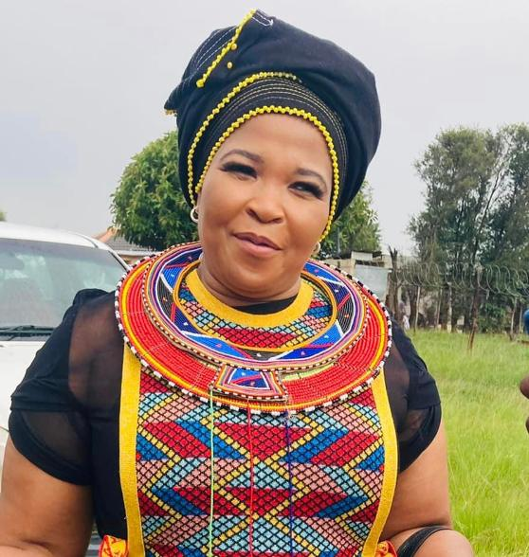

Councillor Ntandokazi Capa is the Chairperson of the Women’s Commission at the Southern African Local Government Association (SALGA) in Southern Africa.

What made you decide to enter local government?
I come from a legacy of leaders. Both my parents were freedom fighters and community leaders. Local government is the primary source of contact for our communities with government. They use it to request service delivery, as well as to communicate with all the other spheres of government. Being a councillor is taking a decision to be the voice of your community. You give yourself to the community so they can use you as a vessel to communicate their needs. They trust you to be able to put their needs first. It was for this reason I joined local government from business, so I can be able to be of service to the people and my country.

What has been your most rewarding experience as a councillor/leader/local government practitioner?
It has been able to watch people’s lives change for the better right before your eyes. Watching a community moving from not having electricity to a fully lit area. Watching roads being built so they can connect the people with the rest of the world. The idea that people put their trust in you to be able to implement their needs so they can be better people tomorrow.

What advice would you give to other women considering entering local government?
My advice would be for people not to enter if they are not passionate about people and development. Once inside, be a sponge, learn as much as you can. Equip yourself with information and skills to be able to execute your duties. Do not be afraid to ask when you are informed of issues. Learn from those before you. Be strong and assertive as these are the skills needed when you are a leader that will sometimes require people to account. Be a leader that is not threatened with being led. Lastly be an advocate for the voiceless.

Why do you think it is important to increase the number and voice of women in local government?
The voice of women in local government has been quietened for so long, as women were used to fill in numbers in councils with no significant voice nor leadership role. Women throughout history have been known to be strong, resilient and compassionate beings. They are able to hold households, raise nations and nurture. That requires you to be able to stand for the truth, and be firm; to be corrective, yet compassionate; to lead, with discipline. When in leadership roles, that skill is transferable to make them formidable. An increase in the number of women will create leaders who understand how to build from the ground up; leaders who are able to be the voice of reason in conflict.

As a woman, what has been your biggest hurdle in becoming a councillor – and in your daily public life?
My biggest hurdle has been getting through to men and women, who thought I got to where I am because of my looks. Secondly, it is because of my parent’s credentials.

I have had to make a conscious choice not to correct anyone but give them time to get to know me as a person, understand what my capabilities are, intellectually, and what my leadership style is, so they can, in time, analyse for themselves what kind of a person I am.

There are a lot of men who do not take women leaders seriously and exhibit a pull-her-down syndrome for women, but it falls upon you to understand that it is not a personal attack but a sign of a broken society, creating a role for you to change their minds through your actions. Let your work speak for itself.

What has helped you the most to continue in your role?
It is the constant, conscious reminder that I am here on this earth, I am capable, I am equal. I have a role to play to make a difference. There are people (the voters) who have put me in the role that I occupy, and have put their trust in me to represent them in the best light. There are young women who, when they look at me, see that it is possible to be anything you set your mind to, regardless of your background.

As a councillor/leader in your community, how can digital technology be used to increase women’s political inclusion?
Digital Technology has reformed every aspect of life as we know it. Whether it is work, communication, shopping or learning. The introduction of electrical devices opened women to an array of opportunities all over the world. It gave women the opportunity to learn new skills and compare with their peers in other parts of the world. People are now able to create profiles, and be influencers. Digital Technology can be used to educate, empower, influence, motivate, support, and involve women to be better versions of themselves so they are able to create stable political environments.

What innovative practices have you found useful in encouraging more women to become more involved in local government in your country?
The ruling party’s encouragement that there be 50/50 representations in all government spheres, induction and training of women councillors so they are fully capacitated to be able take leadership roles in local government. There are opportunities opening up for women. In business there is funding set aside for businesses owned by women. Most of those businesses work with local government.

